AWS Task-3(S3)

Task Description:

- Create a S3 bucket, with no public access and upload files to the bucket & view the logs using cloudwatch for the uploaded files.

OUTPUT:
Step 1: Create a S3 bucket with no public access
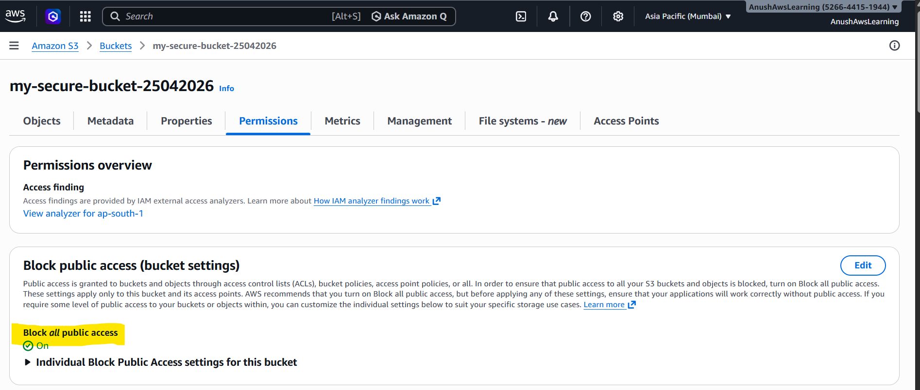

Step 2: Upload the file to the created bucket
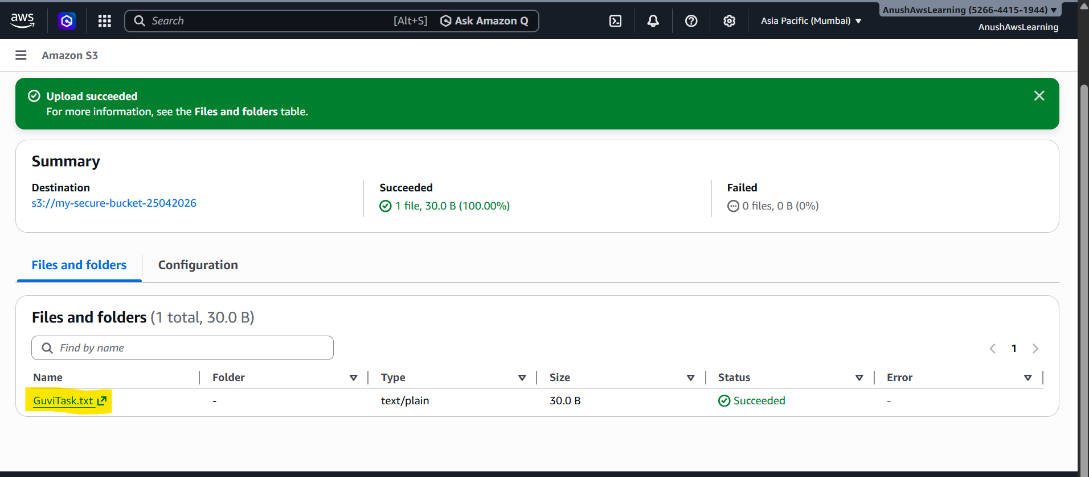

Step 3: Enable CloudTrail for Logging to view the logs using cloudwatch for the uploaded files.
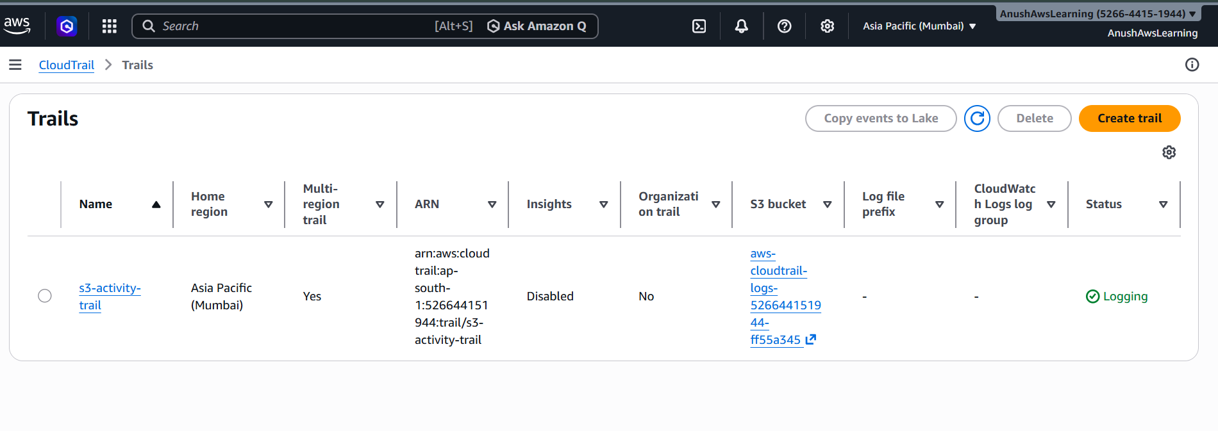

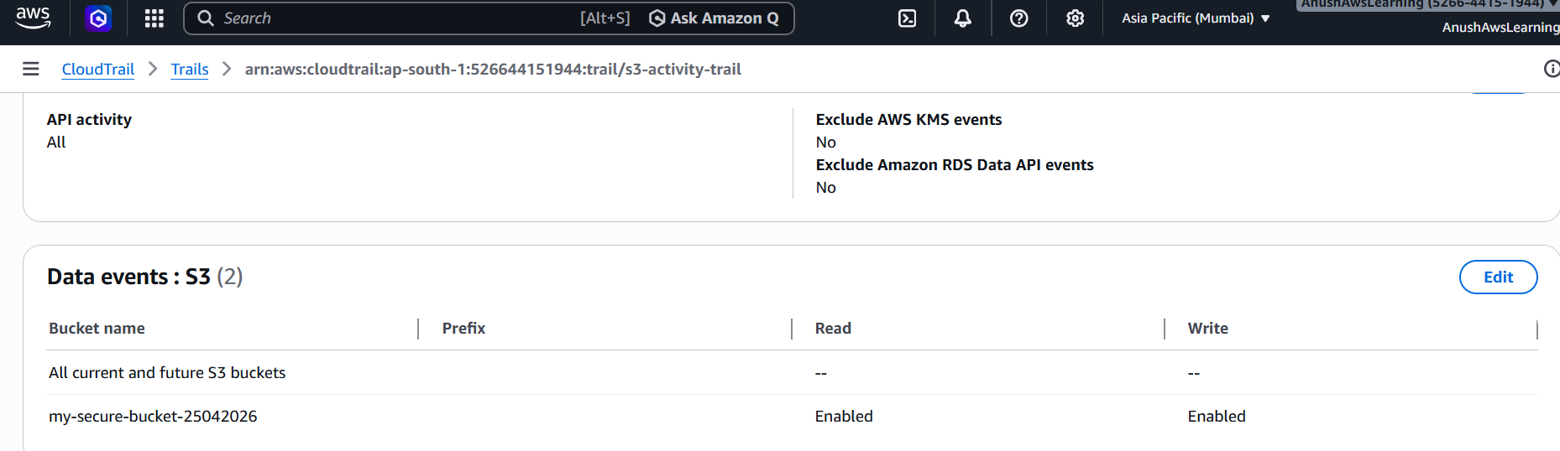

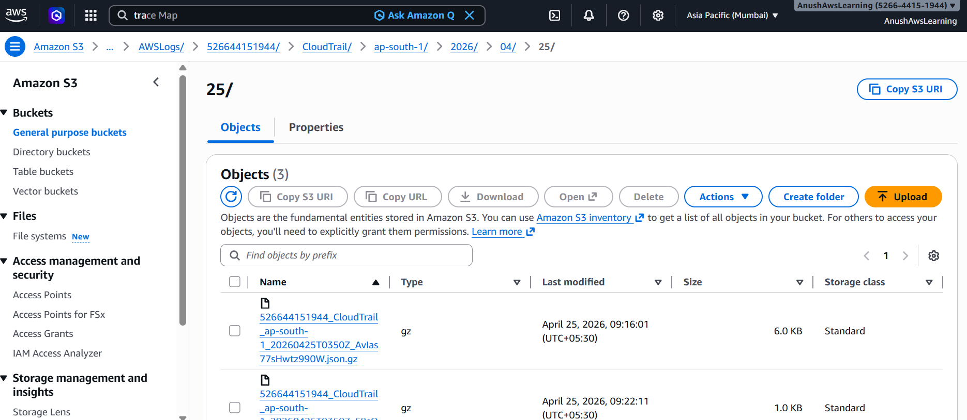

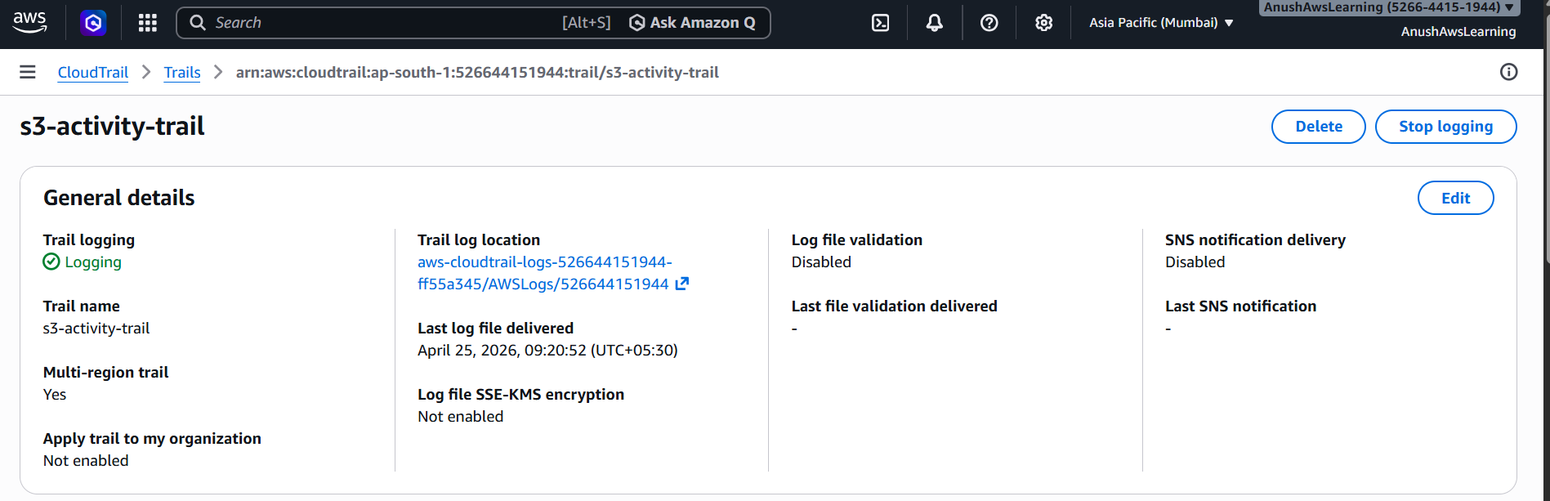
Step 4: Send Logs to CloudWatch

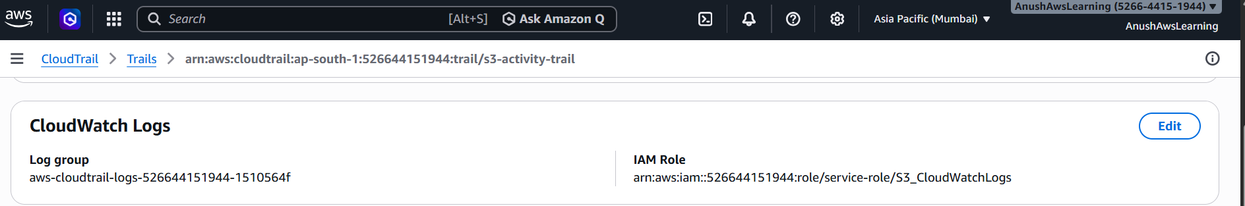

- Launch two ec2-instances and connect it to a application load balancer, where the output traffic from the server must be an load balancer IP address

Step 1: Create two ec2-instances with Webserver enabled
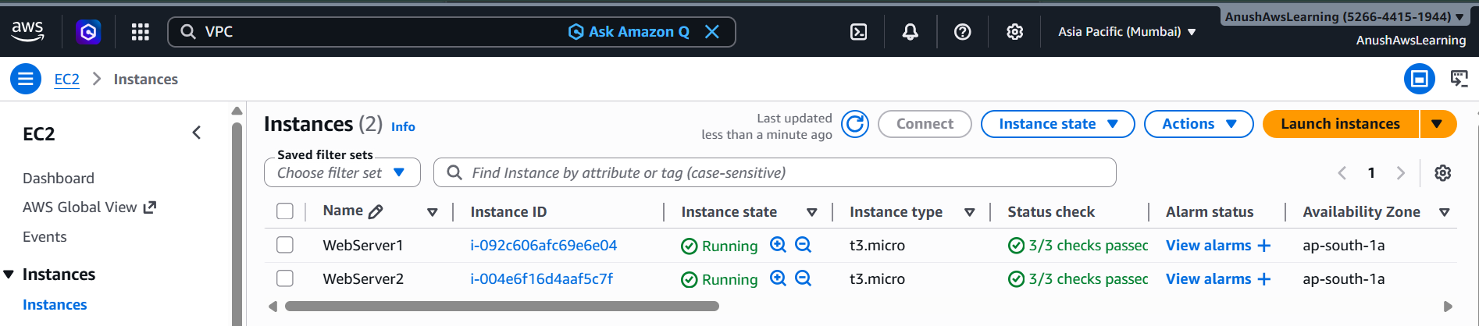

Step 2: Create Application Load Balancer
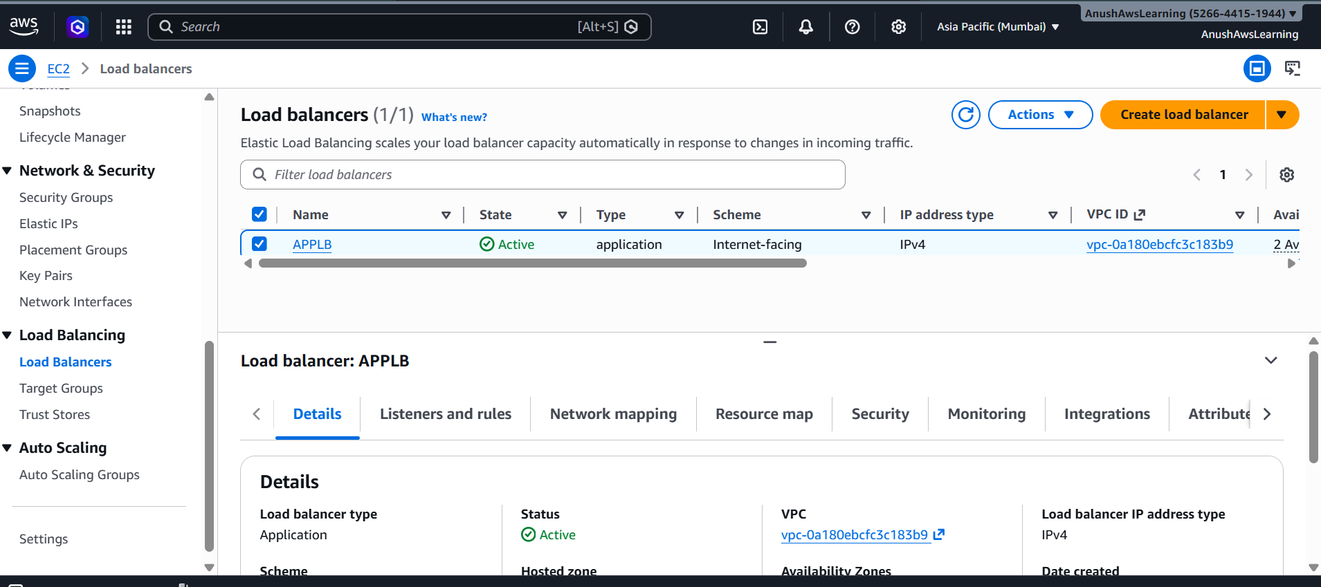
Security Group for LB:
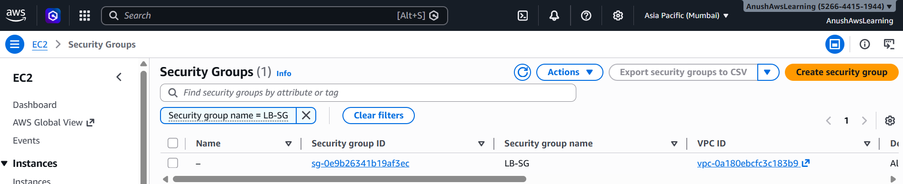
Target Groups for LB:
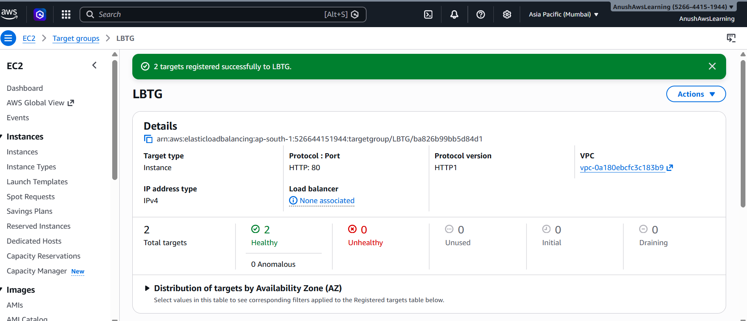
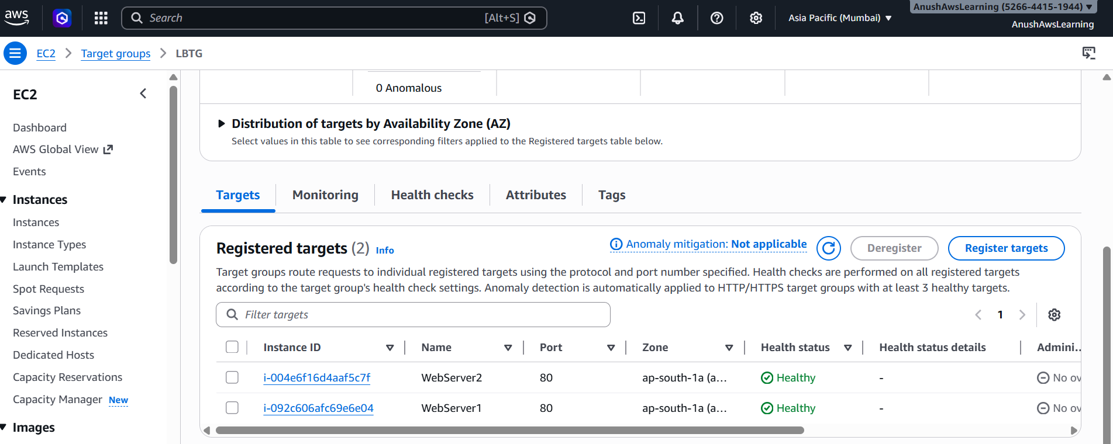

Step 3: Finally check the Webpage Output using Load Balancer DNS:
Webpage is loaded from Instance 1:
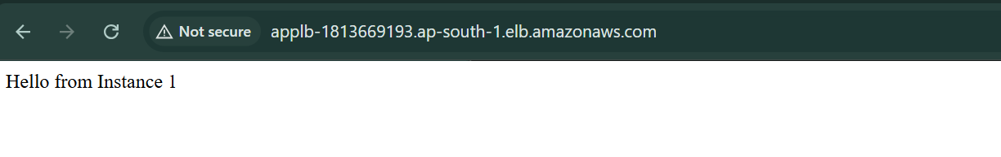

Webpage is loaded from Instance 2:
